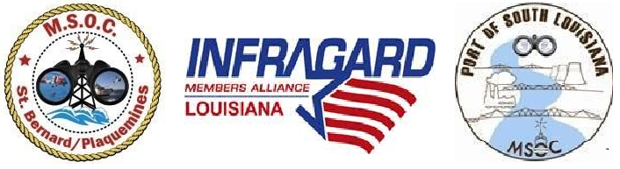
F.S.O. & MARITIME COMMUNITY
WORKGROUP MEETING AGENDA
Thursday, October 3, 2019 / 9:00am – 12:00pm @ Rocky & Carlo’s
Meeting held in the adjoiing Meeting room
Valero Meraux will be sponsoring Lunch

0900 hrs – 0915 hrs
Cdr. Eric J. Acosta, F.S.O. St. Bernard Port, Harbor & Terminal District
- Sign-in sheet / Restrooms/ Call Meeting to Order / Welcome
- Pledge of Allegiance / Moment of Silence / Self-Introductions

0915 hrs – 0945 hrs - TBA (Facility compliance rep.) – U.S. Coast Guard
- 33 CFR 105.237 System for Seafarers’ Access

0945 hrs – 1015 hrs – Larry Tortorich – DHS / TSA / FIO / SitRep
- Kinetic Attacks

1015 hrs – 1045hrs - Capt. Will E. Watson – U.S. CG – Sector New Orleans
- Special Guest Speaker

1045 hrs – 1130 hrs - TENTATIVE – Department Reports/Updates
- FBI–SAC-
- Port of Plaquemines
- Port of South Louisiana
- Port of New Orleans
- LMRPWSSC– Port Security Grants
- LA. Dept. Of Wildlife & Fisheries
- DHS –ICE
- DHS – Customs & Border
- DHS – New Orleans Protective Security Advisor
- Fire Department Reports

- Infragard La Member Alliance (ILMA)
- JTTF – Joint Terrorist Task Force
- LA SAFE – LA State Analytical Fusion Exchange
- LaMA–Louisiana Maritime Association
- OHS-EP
- Sheriff’s Offices Law Enforcement Reports
- TSA-Transportation Security Administration
- USCG Reports

1130 hrs – 1200 hrs - Lunch and Social.

Please RSVP to MSOCStBPlaq@aol.com

Thanks to David Barrett F.S.O. of Valero Meraux for sponsoring lunch at Rocky & Carlo’s Restauraunt!

Sincerely,
Cdr. Eric J. Acosta, F.S.O./F.L.O.

613 W. St. Bernrd Hwy. Chalmette, LA 70043
504-279-8323

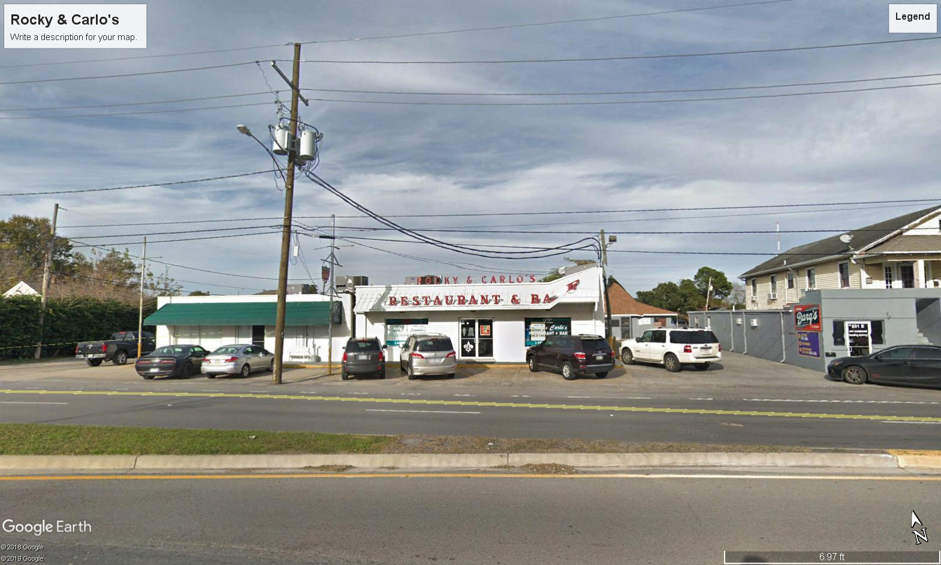

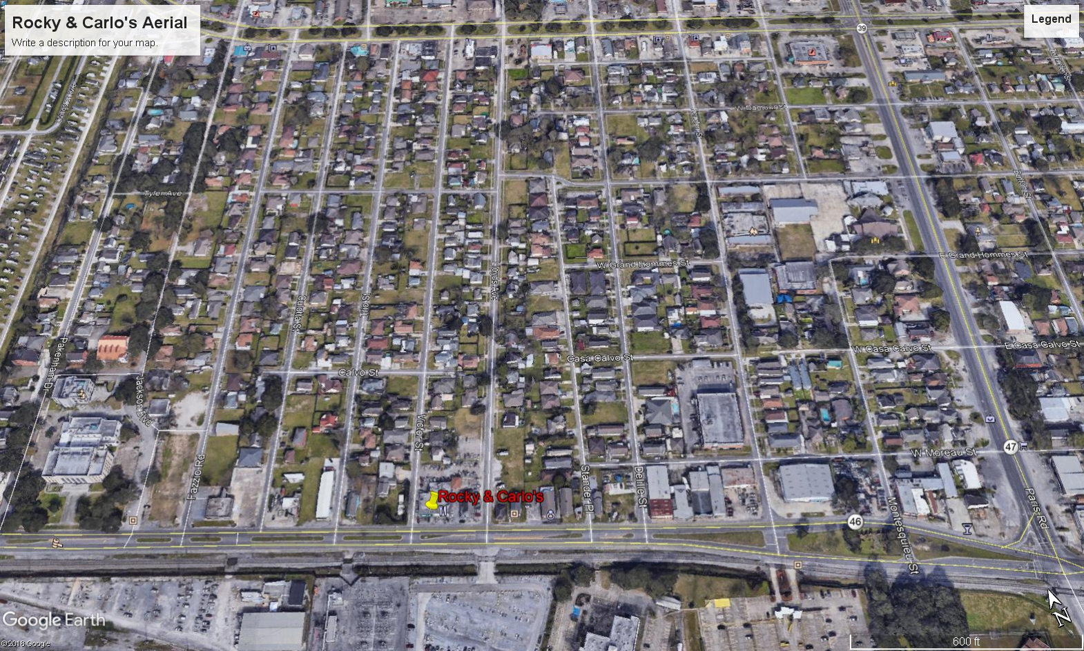
New Orleans
46
47

